**Humanoid Robot V2 with 6 servo motors**

**Abstract:**

Humanoid robots represent a significant milestone in robotics, aiming to emulate human-like capabilities in form and function. This abstract provides a concise overview of the advancements in humanoid robotics, focusing on key aspects such as design, locomotion, sensing, perception, and interaction. In recent years, research and development efforts have propelled humanoid robotics to new heights. Engineers and researchers have made significant progress in designing robots with anthropomorphic features, allowing them to navigate and interact in human-centric environments more effectively. Advances in materials science and manufacturing techniques have led to the creation of lightweight, durable, and agile humanoid platforms. Moreover, advancements in artificial intelligence have empowered humanoid robots with cognitive abilities, enabling them to learn from their experiences, adapt to dynamic scenarios, and collaborate with humans more seamlessly. Natural language processing, emotion recognition, and social interaction skills are among the cognitive capabilities being integrated into humanoid robotic systems.

**Introduction:**

Humanoid robots, with their striking resemblance to the human form and capability to perform tasks in a human-like manner, stand at the forefront of technological innovation. These robots embody the convergence of robotics, artificial intelligence, and biomechanics, aiming to replicate and augment human capabilities in various domains. From assisting in household chores to aiding in complex surgeries, humanoid robots have the potential to revolutionize numerous industries and redefine human-robot interaction. This introduction provides a brief exploration into the fascinating world of humanoid robotics, outlining their significance, challenges, and the transformative impact they are poised to make on society.

**Objective of the project:**

The objectives of humanoid robots encompass a wide range of goals and applications, reflecting the diverse capabilities and potential contributions they can offer to society. Some of the primary objectives include:

1. Human Assistance: Humanoid robots are designed to assist humans in various tasks, ranging from household chores to caregiving for the elderly or individuals with disabilities. Their ability to navigate human environments and interact with objects and people makes them valuable companions and helpers in daily life.

2. Workforce Augmentation: In industrial settings, humanoid robots can augment human labour by performing repetitive or physically demanding tasks with precision and efficiency. They can work alongside human workers, increasing productivity and safety in manufacturing and logistics operations.

3. Exploration and Disaster Response: Humanoid robots equipped with advanced mobility and sensory capabilities can explore hazardous or inaccessible environments, such as disaster zones or outer space. They can gather data, perform rescue missions, or assist in maintenance tasks in environments where human presence is challenging or risky.

4. Healthcare Support: Humanoid robots have potential applications in healthcare, including assisting healthcare professionals in patient care, rehabilitation exercises, and medical procedures. They can provide companionship and mental support to patients, especially in settings such as hospitals or long-term care facilities.

5. Education and Research: Humanoid robots serve as valuable platforms for research and education in robotics, artificial intelligence, and human-robot interaction. They enable researchers to study human behaviours and cognition while providing students with hands-on experience in robotics programming and design.

6. Entertainment and Social Interaction: Humanoid robots are utilized in entertainment, such as theme parks, exhibitions, and interactive installations, to entertain and engage audiences. They can also serve as companions for social interaction, providing emotional support and companionship in settings where human interaction may be limited.

7. Cognitive and Emotional Interaction: Advancements in artificial intelligence enable humanoid robots to recognize emotions, engage in natural language conversation, and adapt their behaviour based on social cues. This capability allows them to interact with humans in more meaningful and empathetic ways, fostering emotional connections and enhancing user experience.

**Components:**

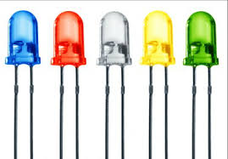 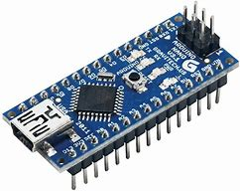 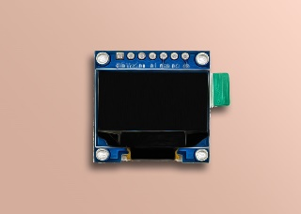 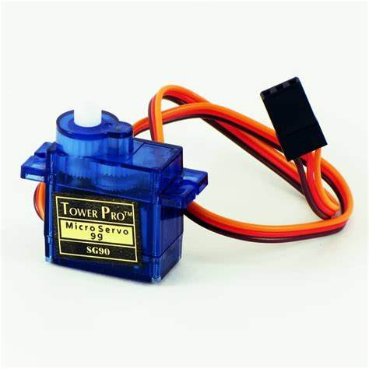

**Hardware Components:**

1. Servo motors x 6
2. Arduino Nano x 1
3. Servo motor driver x 1
4. Led x 2
5. OLED x 1

**Software Requirements:**

1. Python IDE
2. Arduino IDE
3. VSCode, PyCharm (any one of this)

**Requirements:**

For Arduino:

* Install Libraries in **Arduino IDE** Library as:
* Click on Manage Libraries to download Firmata Library.



* Search for **Firamata Library and install it**



* Open File and go to Examples Options and find **Firamata File, c**lick on the **StandardFiramata** and open the file.

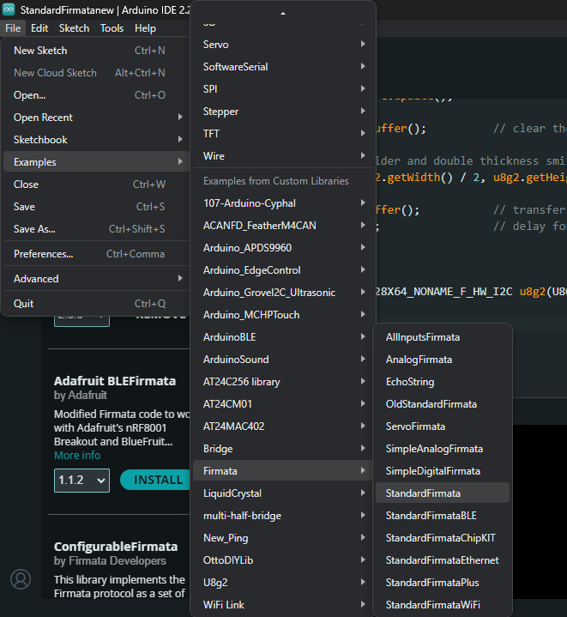

* **Run the code of StandarFirmata**  in the Arduino IDE by checking the Arduino Board and (“**COM Port”).**

**Python Requirements:**

Install required **Libraries in the Python IDE.**

* Install the libraries in CMD or Terminal.
* Libraries to install are:

**-- pip install opencv-python**

**-- pip install cvzone**

**-- pip install pyfirmata**

**-- pip numpy as np**

**Block Diagram:**

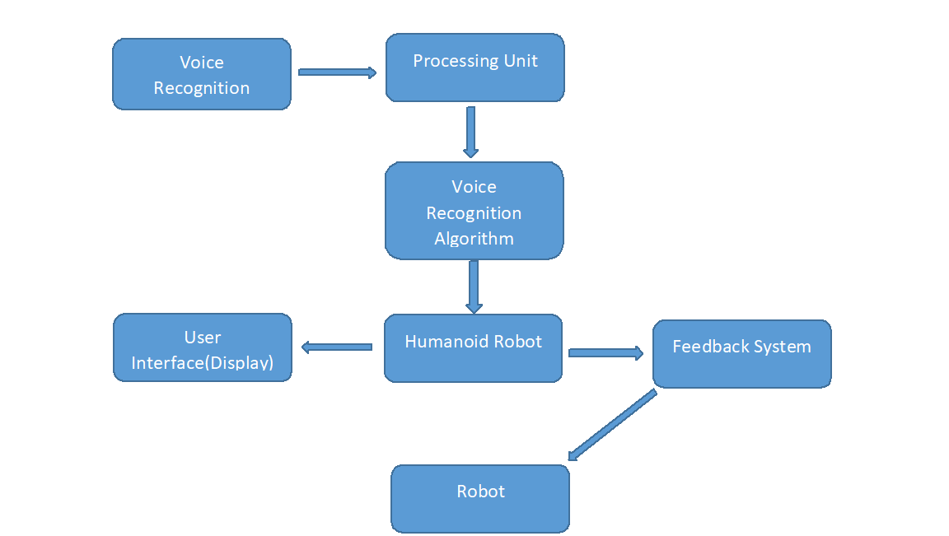

**Development and Functionality:**

The development and functionality of humanoid robots involve a multifaceted process that integrates various disciplines such as robotics, artificial intelligence, biomechanics, and human-computer interaction. The development and functionality of humanoid robots entail a holistic approach that encompasses mechanical design, sensing and perception, locomotion, artificial intelligence, human-robot interaction, task-specific applications, and considerations for safety and ethics. Advancements in these areas continue to drive the evolution of humanoid robotics, expanding their capabilities and potential impact on various aspects of human life.

**Code of Python:**

import speech_recognition as sr

import pyfirmata

import time

# Set up the Arduino board

board = pyfirmata.Arduino('COM5')  # Change this to match your port

# Define servo pins

servo_pins = [8,9,10,11,12,13]

servos = [board.get_pin('d:{}:s'.format(pin)) for pin in servo_pins]

#pin 8 for neck

#pin 9 for hip

#pin 10 for right hand

#pin 11 for right shoulder

#pin 12 for left hand

#pin 13 for left shoulder

# Function to control servo angle

def set_servo_angles(angles):

    for servo, angle in zip(servos, angles):

        servo.write(angle)

    time.sleep(0.1)

# Function to initialize servo positions

def initialize_servos():

    set_servo_angles([90, 81, 0, 0, 180, 180])

# Function to recognize voice command

def recognize_command():

    recognizer = sr.Recognizer()

    with sr.Microphone() as source:

        print("Listening for command...")

        recognizer.adjust_for_ambient_noise(source, duration=1)  # Adjust for 1 second

        audio = recognizer.listen(source)

    try:

        command = recognizer.recognize_google(audio).lower()

        print("Command:", command)

        return command

    except sr.UnknownValueError:

        print("Try to Speak Again …")

        return None

    except sr.RequestError as e:

        print("Could not request results; {0}".format(e))

        return None

# Main loop

initialize_servos()

while True:

    command = recognize_command()

    if command:

        if 'turn right' in command:

            set_servo_angles([51, 51, 0, 0, 0, 180])

        elif 'turn left' in command:

            set_servo_angles([111, 111, 180, 0, 180, 180])

        elif 'assemble' in command:

            set_servo_angles([90, 81, 0, 0, 180, 180])

        elif 'hello' in command:

            set_servo_angles([90, 81, 0, 90, 180, 180])

        elif 'hand' in command:

            set_servo_angles([90, 81, 90, 0, 180, 180])

        elif 'hd' in command:

            set_servo_angles([90, 81, 0, 0, 180, 180])

        elif 'rh' in command:

            set_servo_angles([90, 81, 90, 0, 180, 180])

        elif 'rd' in command:

            set_servo_angles([90, 81, 0, 0, 180, 180])

        elif 'lh' in command:

            set_servo_angles([90, 81, 0, 0, 90, 180])

        elif 'ld' in command:

            set_servo_angles([90, 81, 0, 0, 180, 180])

        elif 'walk' in command:

            for i in range(0, 5):

                set_servo_angles([0, 0, 0, 90, 0, 90]),

                set_servo_angles([0, 0, 0, 0, 0, 0])

                break

        elif 'exit' in command:

            break

**Video Reference of the Working:**

[**Demo link**](https://phntechnologypl-my.sharepoint.com/:v:/g/personal/rutvik_patil_phntechnology_com/Ed134hpcvOZIjYESHUMgYE4BZkDMyso7RUDeZyWuXnR_uQ?e=TiMz6k)

**Conclusion:**

In conclusion, humanoid robots represent a remarkable fusion of cutting-edge technologies and innovative engineering, aiming to bridge the gap between humans and machines. Through meticulous development and integration of mechanical, sensory, cognitive, and interactive capabilities, humanoid robots have emerged as versatile platforms with diverse applications across multiple domains. The journey of humanoid robotics has been marked by significant milestones, from initial attempts to mimic human form and movement to the latest advancements in artificial intelligence and human-robot interaction. These robots continue to evolve, driven by ongoing research and development efforts that push the boundaries of what is possible in robotics.